Match the photo of the landmark to the country.

1. 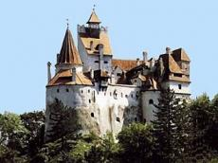 Bran Castle, Brasov
2. Romania
3. Turkey
4. Poland
5. Bulgaria

Answer: a

1. 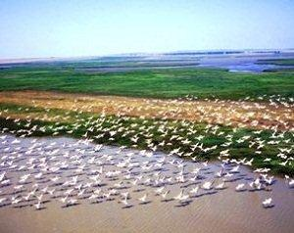 Danube Delta
2. Bulgaria
3. Poland
4. Romania
5. Italy

Answer: c

1. 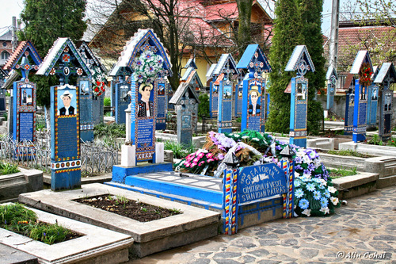 The Merry Cemetery of Sapanta, Maramures
2. Turkey
3. Romania
4. Italy
5. Poland

Answer: b

1. 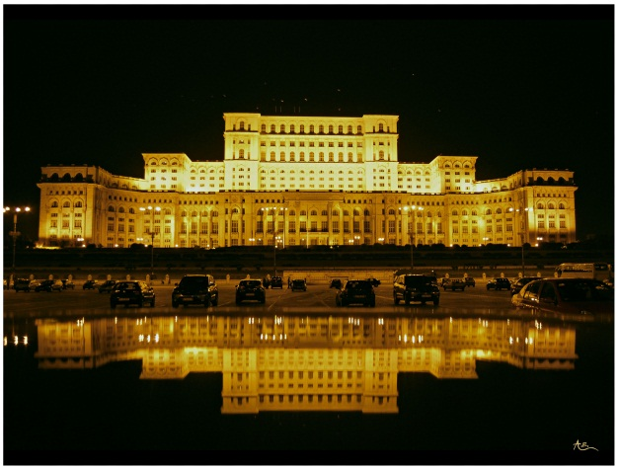 Palace of Parliament at night, Bucharest
2. Poland
3. Turkey
4. Bulgaria
5. Romania

Answer: d

1. 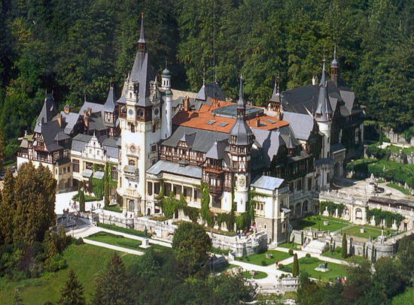 Peles Castle, Sinaia
2. Bulgaria
3. Romania
4. Turkey
5. Spain

Answer: b